Lap Timer Control Function – CGEA1.3

Functional Description

Lap Timer is a part of the Track Application set of features that allows customers to record time and speed for all the laps on a track of their choice.

The Lap Timer feature allows the customer to select one of 3 tracks and have lap times recorded for each. The cluster calculates the average speed based on track length and measures lap times for each lap. The cluster also calculates and display split times comparing current lap time with the previous lap.

The cluster will display current lap time, average speed, the lap number and split time for the track selected by the driver. The lap number is incremented manually by the driver by pressing the buttons on the 5-way switch on the steering wheel. At the end of the “run”, the cluster will also have the capability to allow the driver to save data for each Track that has times recorded.

At the end of the track drive, the customer will have the ability to view the results under the “View/Clear Results” tab in the Track Apps menu. The best track times for each track and the average speed during that track drive will automatically be saved by the cluster. In addition, the customer will also have the ability to save any of the individual lap times for a selected track.

The Lap Timer will not function when the vehicle is driven with a “MyKey”.

The Lap Timer Control Function correlates the VehOverGnd_V_Est signal from the ABS_ESC, the OdoCount signal from the PCM and the Operational mode to process the timer function.

Interfaces

Interface Context Diagram (I/O Block Diagram)
Figure 1.0 Lap Timer Control Function Context Diagram
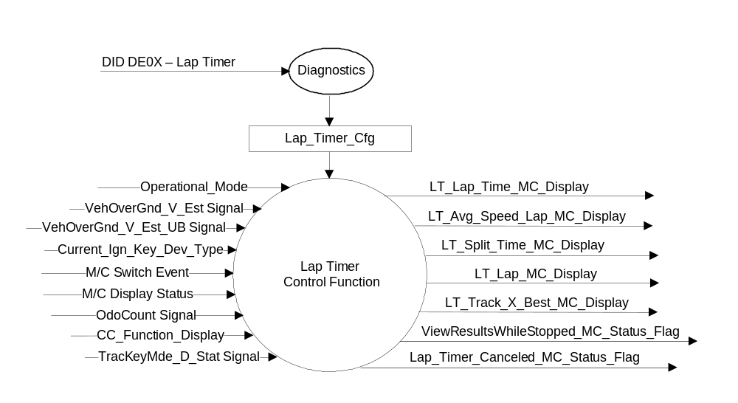

Inputs
- INTERNAL:
  - Operational_Mode: Refer to section Operational Modes
  - Current_Ign_Key_Dev_Type: Used to indicate the type of key currently in use in the vehicle. See MyKey Control Function SPSS for further definition
  - CC_Function_Display: Refer to the CGEA1.3 CADS Cluster Interface Specification for further definition
  - Lap_Timer_Cfg
  - OdoCount
  - M/C Switch Event
  - M/C Display Status
- MUX messages on the CAN Bus

- VehOverGnd_V_Est and VehOverGnd_V_Est_UB Signal
Signal Name | Size (bits) | Detail | Units | Res. | Offset | State Encoded | Min | Max
VehOverGnd_V_Est | 10 |  | kph | 0.01 | 0 |  | 0 (0x0) | 655.33 (0xFFFD)
 |  | Unknown |  |  |  | 0xFFFE
 |  | Fault |  |  |  | 0xFFFF
VehOverGnd_V_Est_UB | 1 |  |  | 1 | 0 |  | 0 (0x0) | 1 (0x1)
 |  | Unchanged_Data |  |  |  | 0x0
 |  | Fresh_Data |  |  |  | 0x1

- OdoCount Signal
Signal name | Size (bits) | Detail | Units | Res. | Offset | State Encoded | Min | Max
OdoCount | 8 |  | meters | 0.2 | 0 |  | 0(0x0) | 50.8 (0xFE)
 |  | Invalid |  |  |  | 0xFF

- TracKeyMde_D_Stat Signal
Signal Name | Size (bits) | Detail | Units | Res. | Offset | State Encoded | Min | Max
TracKeyMde_D_Stat | 2 |  | SED | 1 | 0 |  | 0  (0x0) | 3  (0x3)
 |  | ModeNotDetermined |  |  |  | 0x0
 |  | Active |  |  |  | 0x1
 |  | NotActive |  |  |  | 0x2
 |  | NotUsed |  |  |  | 0x3

Outputs
- LT_Lap_Time_MC_Display
- LT_Avg_Speed_MC_Display
- LT_Split_Time_MC_Display
- LT_Lap_MC_Display
- ViewResultsWhileStopped_MC_Status_Flag
- LT_Track_X_Best_MC_Display
- Lap_Timer_Canceled_MC_Status_Flag

Function/Performance

Operational Modes

Mode | Differentiating Vehicle Conditions
Sleep Mode | Lap Timer Function Inactive
Limited Mode | Lap Timer Function Inactive
Normal Mode | Lap Timer Function Active / Inactive
Crank Mode | Lap Timer Function Active / Inactive

Voltage Levels

Refer to Cluster Features table located in the Operational Modes and Voltage Range Strategies section in this SPSS.

Human-Machine Interface

Visual

Indicator Graphics / Display Format
Example menu structure (refer to program specific menu structure for accurate and approved graphics)

Menu Level 1 | Menu Level 2 | Menu Level 3 | Menu Level 4
Track Apps | Lap Timer | Track 1 | Track X data (X = 1, 2 or 3)  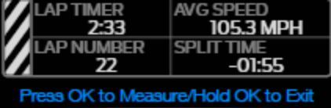
Track Apps | Lap Timer | Track 2
Track Apps | Lap Timer | Track 3

Example graphics for the 4.2” TFT (not all graphics are shown here):
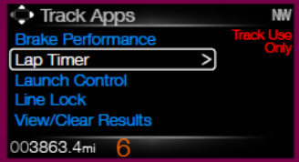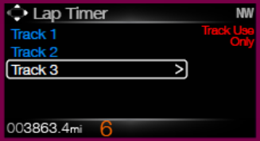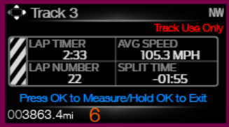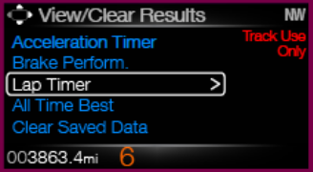

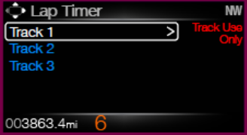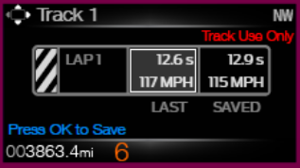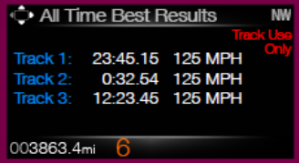

Indicator Color Coordinates

Indicator Characteristics

Audio

None

Switch Control Logic

Not applicable.

System Accuracy

- The real time current lap timer (LT_Lap_Time_MC_Display) shall be displayed in the format of XX:YY:Z (mins, seconds, 10th second). However, upon completion of the lap, the time shall be displayed and saved in the format of XX:YY:ZZ (mins, seconds, 100th second).
- The lap number (LT_Lap_MC_Display) shall be displayed as a XY number (suppress leading zero).There is a max limit of 25 laps for each track selected.
- The average speed of every lap (LT_Avg_Speed_MC_Display) shall be displayed in the format of XXY.Y mph or kph (suppress leading zeros).
- The Lap Timer split time (LT_Split_Time_MC_Display) shall be calculated and displayed in the format of +/- XX:YY.ZZ (mins, seconds, 100th second).

Operation: Performance and Functional

Subsystem Algorithm Flowchart / State Diagram

Figure 1.1 Lap Timer Display Configuration

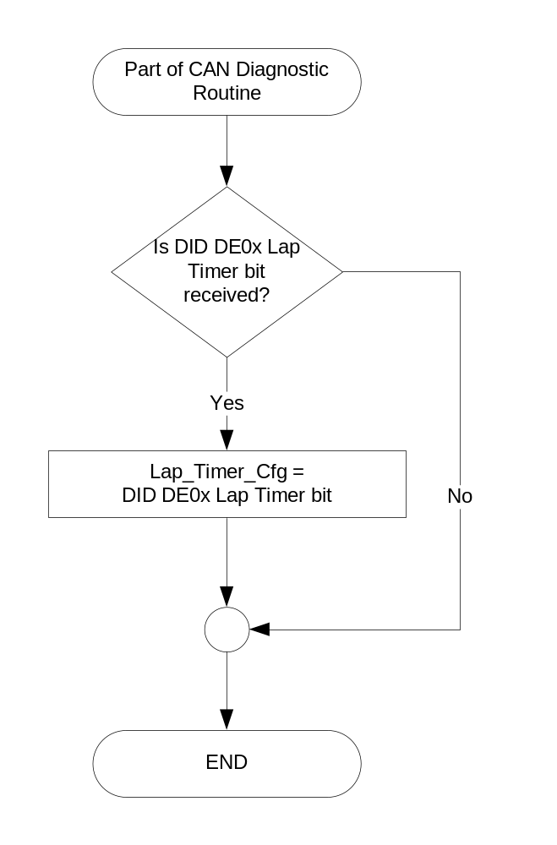

Figure 1.2 Lap Timer Track Length Selection Function
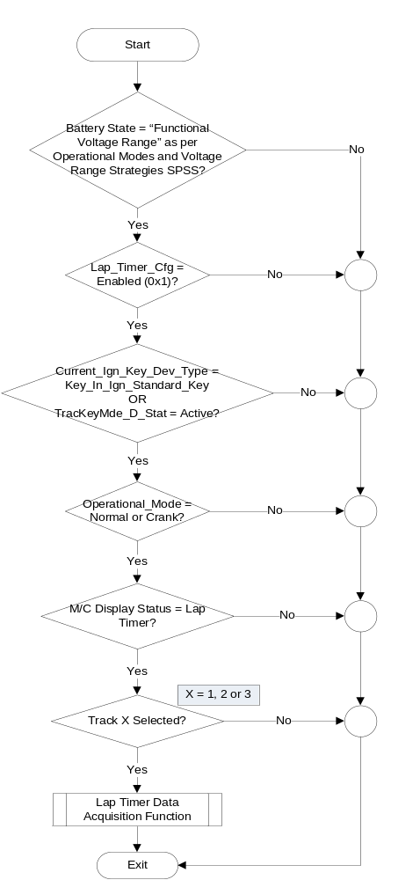
Figure 1.3 Lap Timer Data Acquisition function
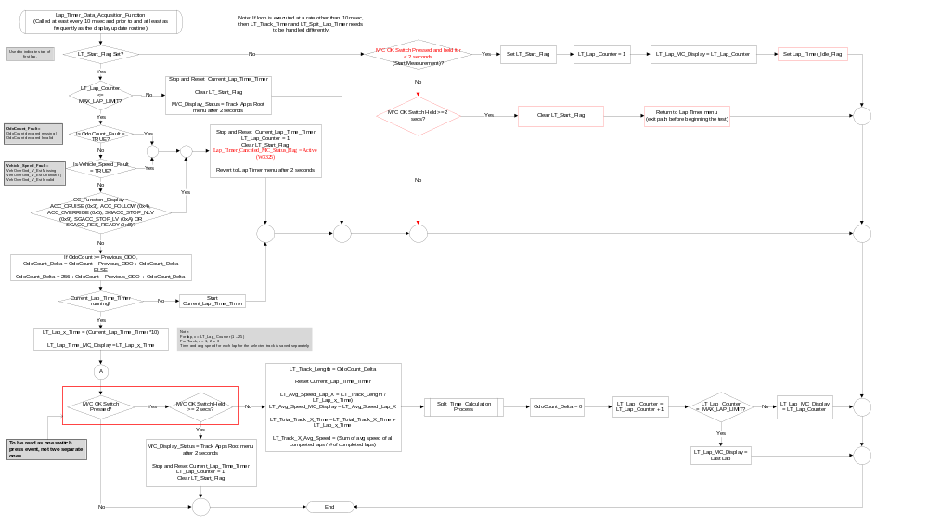
Figure 1.4 Lap Timer Data Acquisition Function Continued
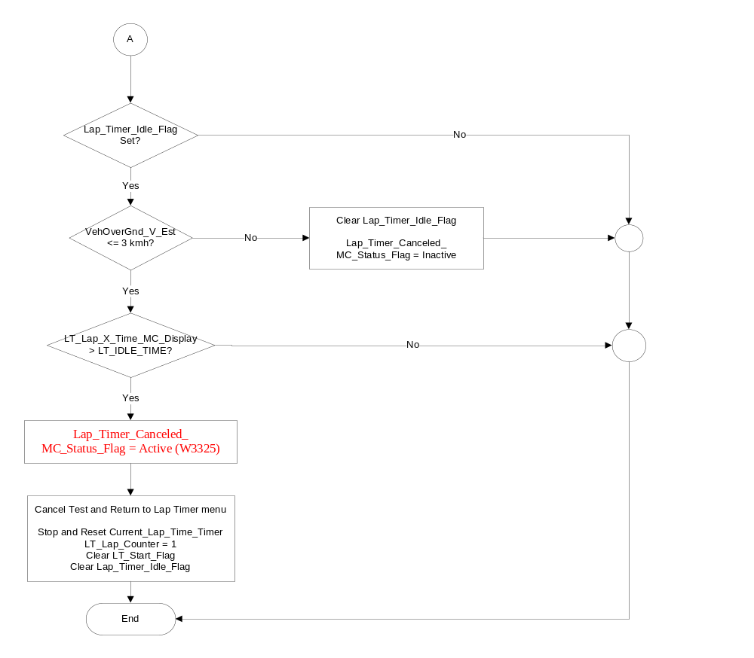

Figure 1.5 Split Time Calculation Process
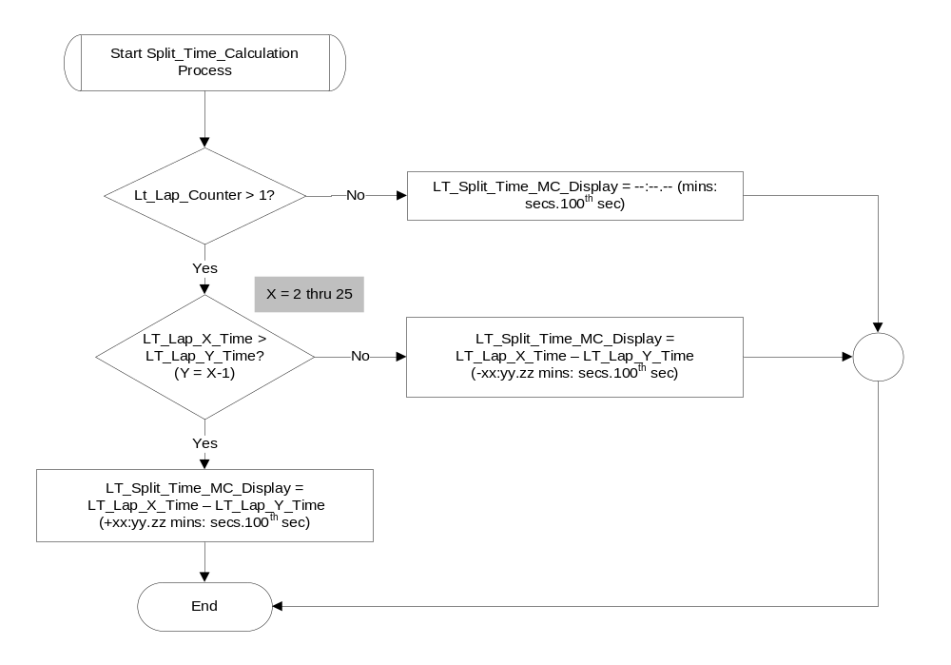
Figure 1.6 View/Clear Results Display Function
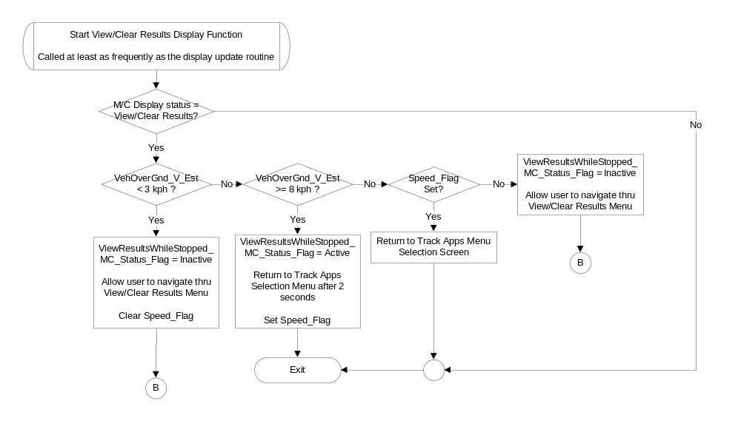
Figure 1.7 View/Clear Results Display Function (Continued)
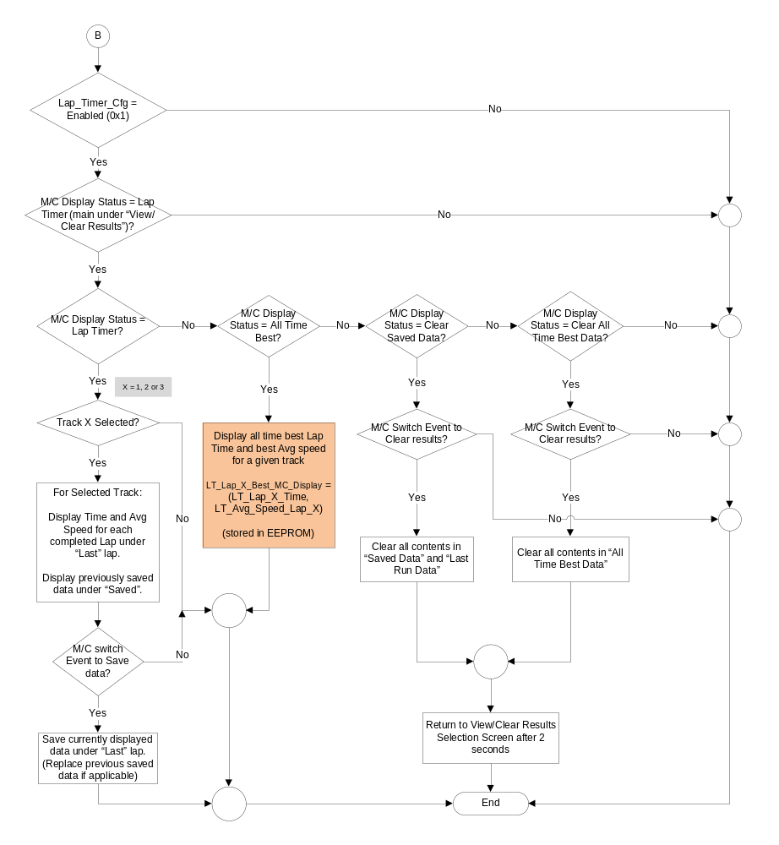

Operation Description (supports algorithm flowchart /state diagram)

- View/Clear Results while Stopped Status Flag to Display Mapping

Lap_Timer_Canceled_  MC_Status_Flag | ViewResultsWhileStopped_  MC_Status_Flag | MC Message ID
Inactive | Active | W3263
Active | Inactive | W3325

- All the screens under the Lap Timer menu shall display “Track Use Only” on the screen at all times.
- The cluster shall use the odometer function to calculate distance traveled.
- The lap timer feature is only operational with engine running.
- The user can select only one of the available tracks to measure lap times at any given time.
- Once the lap timer has been started by the user, the lap distance is calculated by the cluster every time the user presses the “OK” button to advance to the next lap.
- Once the user presses and holds the “OK” button for 2 or more seconds, the lap timer stops even if the user is in the middle of a lap. Data shall be calculated for all completed laps only. Data shall not be calculated for any incomplete laps.
- The cluster shall display lap time on a real time basis. The “real time” lap timer shall be displayed accurately to 10th of a second. However, the final time for each completed lap shall be displayed and saved to an accuracy of a 100th of second.
- Split time and average speed are calculated at the completion of each lap. Split time shall be displayed and saved to an accuracy of 100th of a second.
- Once the user presses the “OK” button to start a new lap, the average speed and split time shall be shown as dashes since calculation of those variables cannot be calculated until end of the lap. Split time shall also be displayed as dashes for the first lap.
- If at any given time during the process, if any of the input signals is declared missing, invalid or unknown, the lap timer shall be stopped and the track drive shall be canceled and the cluster should revert back to the Lap Timer menu. The cluster shall save results for all completed laps, discard data for incomplete laps, activate W3325. The current lap timer and lap number shall be reset to their initial value as well.
- The cluster shall save data for each lap for a given track automatically after completion for every lap. This data shall be saved for the current key cycle so that the user can view it after completing the track performance.
- If more than one track drives are carried out within the same key cycle, the cluster shall save results for each completed lap for all the completed tracks.
- The user shall have the ability to save each of the lap data (time and speed) while viewing the lap time results under the “View/Clear Results” menu.
- While under the “View/Clear Results” menu, the user can scroll through the lap data using the Up/Down buttons and press OK to save individual results as required. The Up button will decrement the lap # and the Down button shall increment the lap #.
- When user enters “Track X” from the Lap Timer menu, the View/Clear results shall always start with last run data of the first lap and progress from that point.
- The cluster shall save the total track time and average speed for that particular track after completion of a given track drive. This data shall be saved throughout key cycles so that it can be compared with future or past performance on the same track to calculate and display “All Time Best” results.
- Once a better track time has been calculated for a given track, the cluster shall automatically replace the data under “All Time Best” results (if applicable) for the given track.
- The Lap Timer feature shall not be available if Lap_Timer_Cfg is set to disabled (0x0) or if the vehicle is driven using MyKey.
- Anytime the user activates Adaptive Cruise Control, the test shall be canceled, the cluster shall display the “Test Canceled” screen and stop and reset all timers. No data shall be saved for an incomplete lap.

Function Safety Classification (EMC)

Class B

Memory Storage
Parameter Name | Description | Value at Battery Connect | Value at Module Wake-up
VehOverGnd_V_Est Signal | Vehicle speed input from ABS_ESC. | 0 kph (0x0) | 0 kph (0x0)
VehOverGnd_V_Est_UB Signal | Vehicle speed update bit | 0 (0x0) | 0 (0x0)
Odocount Signal | Odo count input signal from PCM | 0x0 | Do not init
TracKeyMde_D_Stat signal | Input from BCM providing status of TracKey | ModeNotDetermined (0x0) | ModeNotDetermined  (0x0)
CC_Function_Display | Input from CADS spec
LT_Lap_Time_MC_Display | Output Time measured for each lap on a given track. | 00:00:00 secs | 00:00:00 secs
LT_Avg_Speed_MC_Display | Output Average vehicle speed calculated for each lap on a given track. | 0.0 mph/kmh | 0.0 mph/kmh
LT_Split_Time_MC_Display | Out split time calculated between current lap and the previous lep. | 0.0 secs | 0.0 secs
LT_Lap_MC_Display | Output lap number displayed | 1 | 1
LT_Track_X_Best_MC_Display | Output best track information display | Use Stored Value | Use Stored Value
ViewResultsWhileStopped_MC_Status_Flag | Output warning flag activated when trying to access results while driving. | Inactive | Inactive
Lap_Timer_Canceled_MC_  Status_Flag | Output warning flag | Inactive | Inactive
Lap_Timer_Cfg | State indicator for feature presence controlled via CAN at EOL at VO plant. Set to Disabled at Cluster Supplier Manufacturing Plant | Use Stored Value | Use Stored Value
Operational_Mode | 4 state indicator for cluster operational mode | Limited | Limited or Normal or Crank

Parameter Name | Description | Unit | Res. | Range/Value
LT_Lap_Counter | Counter to keep track of laps completed on a given track | # | 1 | 1 to MAX_LAP_LIMIT
MAX_LAP_LIMIT | Maximum number of laps allowed on a given track | # | 1 | 25
MAX_LAP_TIME | Maximum time allowed for each lap, after which lap timer will be aborted. | sec | .01 | 599.99 seconds  (09:59.99 mins)
LT_IDLE_TIME | Time after which lap timer function will be aborted if vehicle speed remains <= 3 kph. | Mins | 1 | 2 minutes

Prove Out

No

Error Handling

Missing Message Strategy

The signals will be declared missing as per the Diagnostics section of this SPSS.

DTCs states and history will be determined as per the Diagnostics section of this SPSS.

If Lap_Timer_Cfg = Disabled, the cluster shall never log a missing message DTC due to this feature.

Invalid Message Strategy

The signals will be declared invalid as per the Diagnostics section of this SPSS.

DTCs states and history will be determined as per the Diagnostics section of this SPSS.

If Lap_Timer_Cfg = Disabled, the cluster shall never log an invalid data DTC due to this feature.

Unknown Message Strategy

The signals will be declared unknown as per the Diagnostics section of this SPSS.

DTCs states and history will be determined as per the Diagnostics section of this SPSS.

If Lap_Timer_Cfg = Disabled, the cluster shall never log an unknown data DTC due to this feature.

Diagnostics

Self Test
None

Engineering Test Mode
Reference section “Dealer / Engineering Test Mode (ETM)”

Part II Performance
Reference Part II Diagnostic Specification

Supported Diagnostic Trouble Codes (DTCs)

DTC | Description
C12100 | Lost Communication with ABS_ESC
C41581 | Unknown Data Received from ABS_ESC
C41500 | Invalid Data Received from ABS_ESC

DID DE0X
Block  Num | Block Description | Size (bits) | Byte | Bit | State: Description | "0" | "1" | Default | Comments
PACKETED BLOCKS
$0X | Option Content (B&A) | 1 | * | * | Lap Timer | Disabled | Enabled | Disabled
*Byte and bit location to be identified in Part II Specification for this cluster

Reference Specification

- Func. Criticality EC-0048
- Mod. PWR-up / Reset EC-0049
- Low-High Vol. Perform. EC-0058
- Jump Start EC-0062
- Instr. & Gauges (indic. Grad) IS-0015
- Oper. Voltage Perf. IS-0052
- Oper. Voltage Func. IS-0053
- Symbol Usage 01-0238 / 01-0239
- Symbol Leg. 01-0240
- Placement - Parts Loc. 03-0001
- Glare/Reflections 16-0068
- Reflection 17-0018
- Harmony: Graphics / Font / Ill. 17-0040
- Ergo - Access. 17-0052
- Ergo - Operablility 17-0053
- Control & Display Loc. 17-0060
- Logical grouping Function and Usage 17-0062
- Assoc. of Controls with Disp. & elem. 17-0063
- Ill. Controls & Disp. 17-0074
- Id. Legibility 17-0081
- ID. Coding / Labeling 17-0083
- Logic of Op. 17-0120
- Op. Stereotypes 17-0121
- Interpretation 17-0122
- Feedback 17-0124

Revision History

STSS Module Revision History

Revision Level | Name | Change Description | Date
1.0 | V. Patel | Initial release for CGEA1.3, feature owner Drake, Chuck (S550 program team) | 09/18/2013
1.1 | V. Patel | The purpose of this release is to address and clarify questions raised by the supplier. There is no change in overall functionality of the feature. All the updates are in Red.  - Section 1.3.5.1:  - Figure 1.3: Updated flowchart to activate W3325 and return to Lap Timer menu if Vehicle speed signal is declared missing, invalid or fault (Same behavior as OdoCount Missing and invalid).  - Figure1.3: Also added a box around OK switch press event (to increment lap number and cancel) to show that it is one event and not two different switch press events.  - Figure 1.3: Updated the check for OK button pressed so that the user can exit out of the Lap timer trial if the OK button is pressed for >= 2 seconds even before beginning the trial (after selecting a given track).  - Moved the check for ACC flags from figure 1.4 to figure 1.3 (just before the odo calculation block)  - Figure 1.4: Updated flowchart to activate W3325 if Lap timer exceeds max time allowed for a lap.  - Figure 1.3, figure1.4: Updated flowchart to improve the logic to exit out of the trial if vehicle speed is lower than threshold for given time.  - Figure 1.7: Once data is cleared via the menu, the display needs to return to the “View/Clear Results” instead of “Track Apps menu” to be consistent with other features within Track Apps.  - Figure 1.5: Updated figure to show dashes for Split time during the first lap since the cluster does not calculate lap time until the 2nd lap. This matches the requirement in section 1.3.5.2.  - Section 1.3.5.2: Added a statement to reflect the update in figure 1.3. | 06/23/2014
1.2 | V. Patel | Purpose of this update to resolve an issue in feature functionality. Currently, the “All Time Best Results” display the best time and average speed for total track time. Instead, the “All Time Best Results” needs to display time for the best lap and highest average speed on a given track. (Direction provided by Chuck Drake, feature owner)  Section 1.3.5.1, figure 1.7: Updated flowchart to display the correct information. Best lap time and highest avg speed for a given track. Updated process block shown in orange. | 3/19/2015
1.3 | V. Patel | Update to clarify supplier question regarding the input to be used to determine if TracKey is active for this feature. Since it is a CAN input from BCM, the spec is updated to define it explicitly. There is no change to the functionality of the feature.  - Section 1.2.1, figure 1: Added the TracKeyMde_D_Stat Signal as an input.  - Section 1.3.5.1 Figure 3, figure 4: Updated the diamond that checks for type of key used. Replaced the use of MyKey with Standard Key and TracKey inputs.  - Section 1.3.5.4: Added the TracKeyMde_D_Stat Signal as an input. | 4/23/2015

